Equipment Usage
Please utilize this guide to help you setup your presentation. If you have any questions, please contact IT.

PTZ Pro 2 Camera
This camera is used to get a better view of the presenter. The usb cord goes to the computer and the round end goes to the camera for data & power. It should register as PTZ Pro 2 camera. Please select PTZ Pro 2 by pressing the up arrow on the “Start/Stop Video”. If you do not see PTZ Pro 2, please double check the connection. There is a remote for the camera or you may adjust it manually. Every time the camera turns off, it will reset its position.
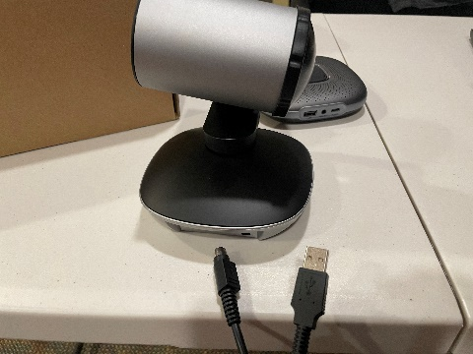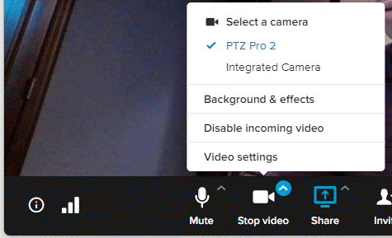

Anker Power Conference
This device is used as a speaker and microphone. The usb cord goes into the computer and the other end goes to the device, which powers it and sends data. On the up arrow of the mute/unmute in Ringcentral, select “Anker PowerConf” for microphone and speaker. You should see some glowing color on the device if it’s connected. Keep the device close to the presenter and far away from other devices (to avoid interference).
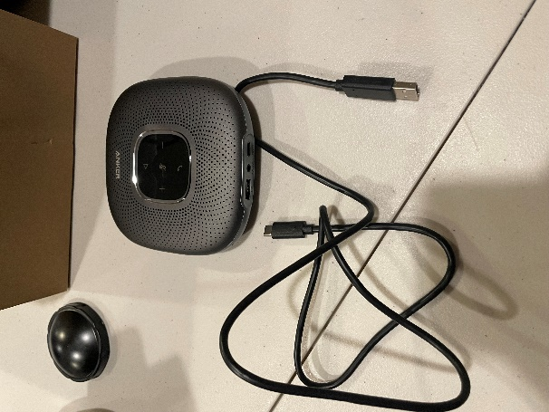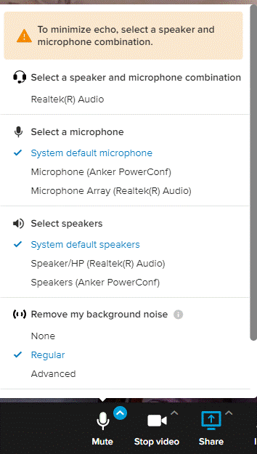

Projector
The Epson project connects via HDMI to your computer. It acts like a second monitor/screen. You’ll need to setup the white background drop for the projector. There is a little plastic leg stand for it. It’s the grey little button in the middle front bottom of the projector. Press it to release the leg and adjust as needed. Make any proper adjustments using the buttons on the projector or using the remote.
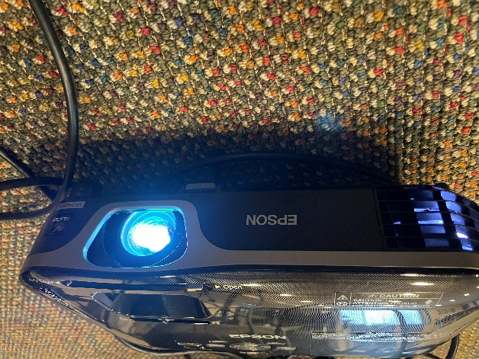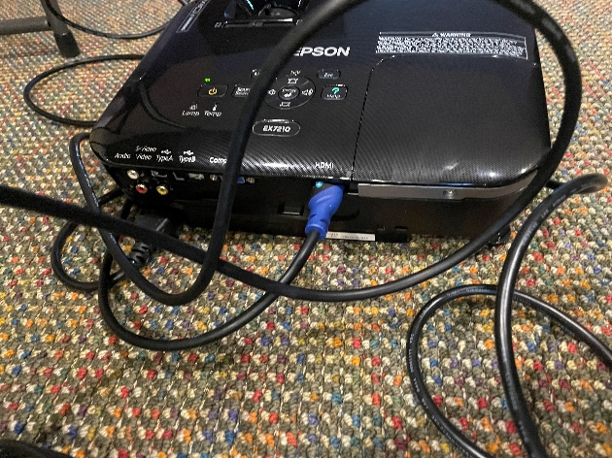

Yeti Mic
This is an alternative mic/speaker that you may use by connecting to it via usb. Select “Yeti…” from the up arrow under the mute/unmute option in RingCentral.
